Case 6-Afr-Congo-N’kisi-Kuba Bwoom-Connection
Note: The Democratic Republic of the Congo (DR Congo) has been known as, in chronological order, the Congo Free State, Belgian Congo, the Republic of Congo-Léopoldville, the DR Congo and the Republic of Zaire, before returning to its current name the DR Congo.
Note: The Kongo people (singular: Mukongo, pl. Bakongo) speak Kikongo, a Bantu language, who have lived along the Atlantic coast of Central Africa, in a region that, by the 15th century, was a centralized and well-organized Kongo Kingdom but is now a part of three countries: the DR Congo, the Republic of the Congo and Angola.

Pygmy Knowledge in Central Africa among the Kongo and Kuba Peoples

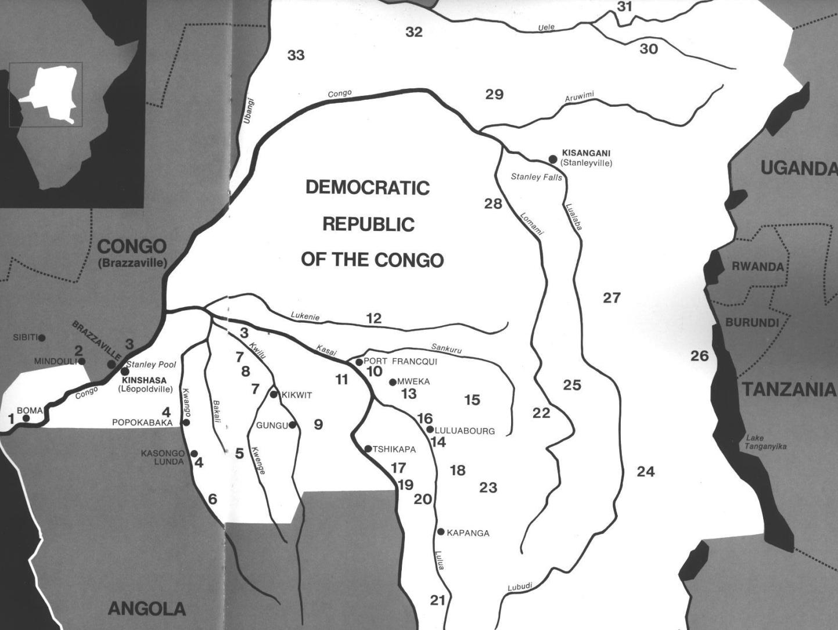
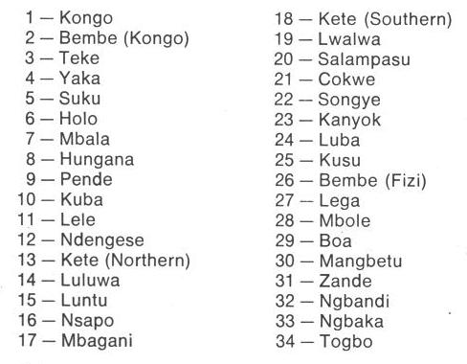
Fig. 1. Map of Kongo Cultures, West Central Africa. After Walker Art Center 1967.

1. Pygmy Knowledge in the Kongo Kingdom.

Around 1100 AD/CE Ntinu Lukeni (or Weni, son of a local king) in the Bantu Kongo-speaking Vungu (Bungu) Kingdom on the north bank of the Congo or Nzadi River (a truncation of thr KiKongo nzadi o nzere, "river swallowing rivers" (Forbath 1977;19), invaded the south bank of the river in order to establish a new Kongo speaking Kingdom. There he established a system of tariffs along the river charging traders to transport their goods. He also began requiring the local inhabitants to speak the Bantu Kongo language. He established a series of treaties with local chieftains so that his men would marry their daughters ensuring loyalty to his hegemony. Among these peoples were three groups of diminutive aboriginal inhabitants or Pygmies: BaMbaka-mbaka, Mbwidi-Mibodila and BaFula Mengo. These were characterized by the Kongo as having hydrocephaly (large heads), which physically and symbolically referred to their perceived knowledge of the riches of the forests in which they lived and the medicines they derived from local plants. This esteem for Pygmy knowledge was observed at the courts of Mbanza Kongo and Loango where the King of the Kongo entertained the chief medical specialists of the Kingdom who regarded the these diminutive aboriginal inhabitants of the Kingdom as, in fact, Pygmies.

2. Connection of the Kongo People with the Kuba-Bushongo (Bushoong)
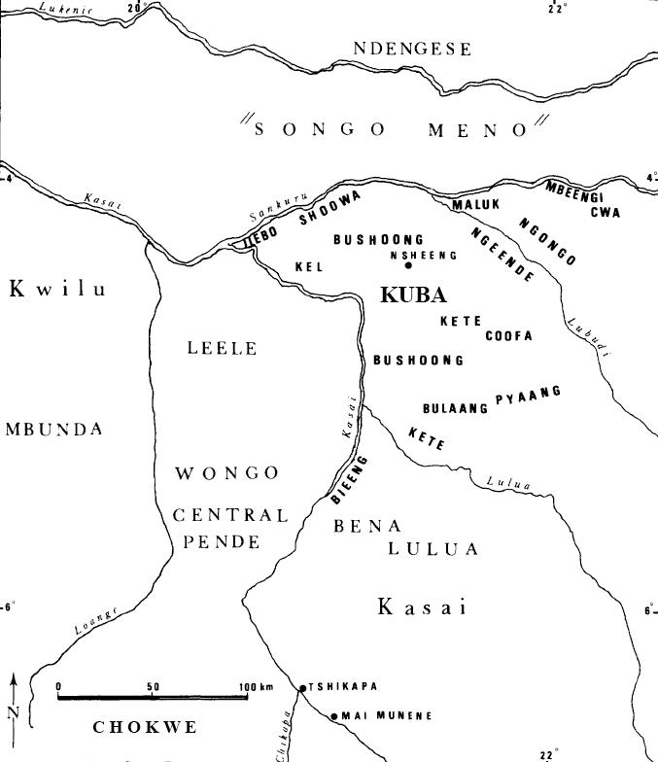
Fig. 2. Kuba territory with tribal groups in bold typeface (after Brett-Smith 1983).

The Kuba peoples to the east of the Kongo peoples also had contact with these “Pygmies” as well. They recognized the superior knowledge that these people had of the riches of the rain forest and therefore they ensconced them as a prominent feature of their culture. Tradition relates how a Kuba woman carved a face on a calabash that became the original model for initiation masks. Later, the invention was adopted for male initiation rites, and today remains a male privilege. Once masked, the Kuba dancer assumes the persona of the spirit of the mask as its apotheosis (cf. Torday 1910:250; Vansina 1955:140).

The Kuba have three royal mask types: 1) Mwaash a Mbooy, representing Woot and the king; 2) the wooden face mask, Ngady Mwaash a Mbooy, the incestuous sister-wife of Woot; and 3) the wooden helmet mask, Bwoom, the Pygmy, also the challenging brother and the common man. These characters appear in a variety of contexts including public ceremonies, rites involving the king, and initiations. Although their dances are generally solo, together the three royal masqueraders re-enact Kuba myths of origin (Cornet 1982: 254, 256; Roy 1979:170).

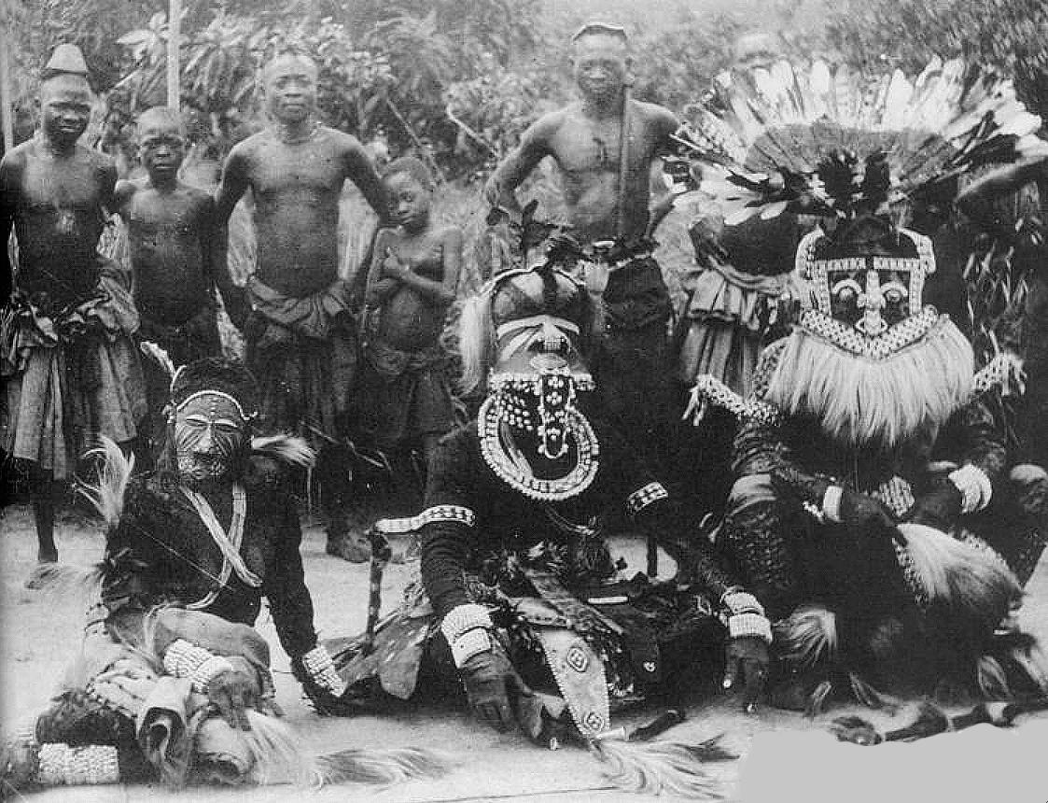
Fig. 3. Kuba masqueraders, Nesheng, southern Kasai River, 1909. Royal Kuba Masqueraders, Nsheng, Kasai, Congo, 1909 (after the Library of the University of Michigan, Image 344206, http://quod.lib.umich.edu/h/hart/x-344206/03d100403). Bwoom masquerader, front, center, of hydrocephalic (large-headed) aboriginal pygmy symbolizing profound local knowledge of the forest and its medical riches. Front-center, right: Mwaash aMbooy, representing Woot, the founding ancestor of the Kuba. Front–center left: Ngady Mwaash aMbooy, the incestuous sister-wife of Woot.
The Bwoom mask proper dates to the early eighteenth century. A royal mask attributed to King Miko mi Mbul dates to ca. 1800-ca. 1835 (Cornet 1975: no. 63, p. 89). An eighteenth-century song for the son of King Kot aNce refers to the first recorded instance of adorning Bwoom masks with cowries and beads., implying that earlier masks were devoid of these accoutrements at signified wealth. Many variations of the mask evolved perhaps from prototypes (Vansina 1978: 216).

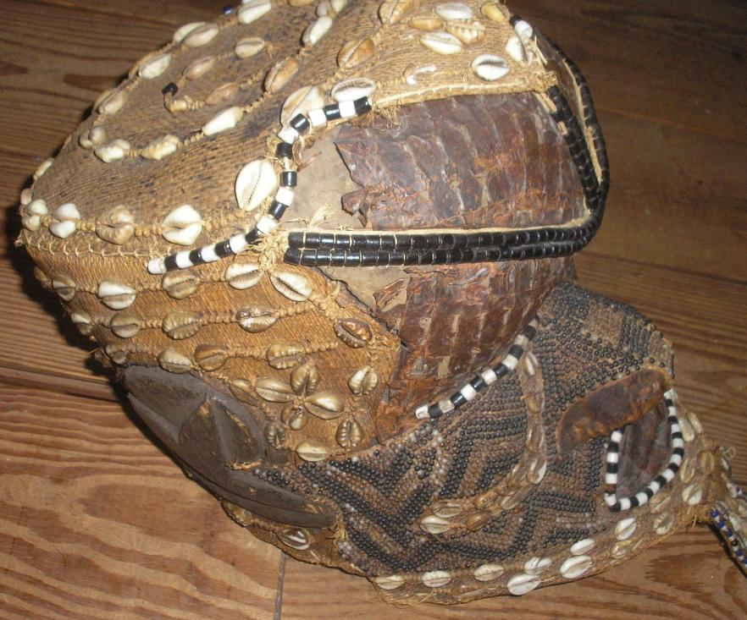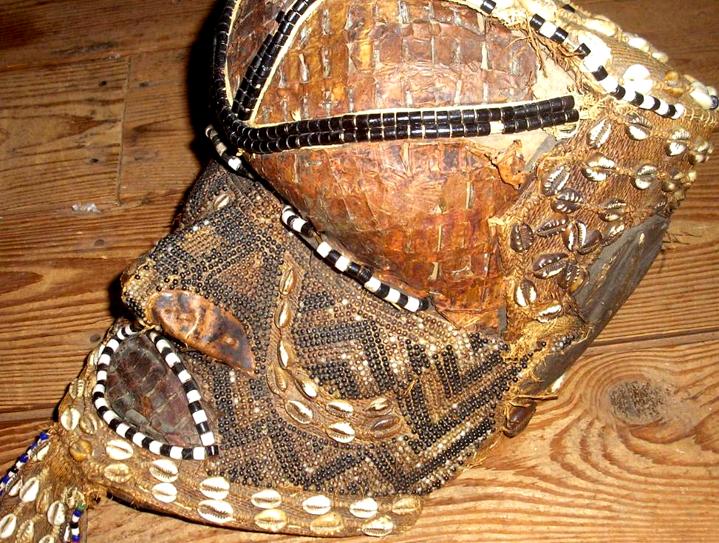

Fig. 4 a-b. Bwoom helmet mask, Kuba-Bushongo-Bushoong; Democratic Republic of Congo, Atlantika Collection. Wood, hammered copper, raffia fiber, animal skin, cloth, beads, cowrie shells. This large, proportioned, hollow wooden mask probably dates to the early twentieth century. The perimeter, temples, pate and back are decorated with beads and cowrie shells (used in the area as currency). A pendant “beard” has cowry shells surrounded by beads. The broad face has an incised zigzag motif similar to the geometric keloid scars that are applied to the Kuba body and which are replicated in textile designs (Cornet 1982:266; see Fig. 3). In this example, the carved wood understructure is covered with copper sheeting that is extended by a beard made of hide and accented throughout by beadwork. Beads also embellish the contours of both the eyes and the mouth. A series of bead bands crosses the surface of the face, one from the crown of the head to the tip of the nose and another from one side of the head to the other, bisecting the eyes. The cheeks are outlined with dual bands of cowry shells, and the crown is covered with animal skin surmounted by three bands of two strand ancient beads.

The Bwoom mask has three aspects: 1) as a Pygmy, 2) as a challenging brother, and 3) as a common man:

1) The Bwoom as a Pygmy. The Pygmies are forest-dwelling, hunter-gatherers and know this seemingly impenetrable landscape intimately. The ancient idea that a society's landscape is its own because its ancestors are buried there is central to Pygmy cosmology. The Kuba recognized this ancient idea. When they migrated into Pygmy forests they realized that their hope of a successful life in this landscape was to ally themselves with the Pygmies and learn the Pygmy lore of the ancient ancestral forest spirits (cf. Ehret 2002:50; Schadeberg 1999). Appropriately, Bwoom is the first spirit seen as an apotheosis by nkan initiates.
2) The Bwoom as the challenging brother. This aspect of the Bwoom invokes a ritual reenactment of the struggle for social power of the challenging brother who seeks both the throne of his brother, Mwaash A Mboy, and the king's wife, Ngaady A Mwaash. Bwoom, therefore, supports the challenge of authority.
3) The Bwoom as the common man. This role of the Bwoom fostered the respect of the individual's rights and the need for consensus among commoners as necessary checks and balances to offset royal authority.
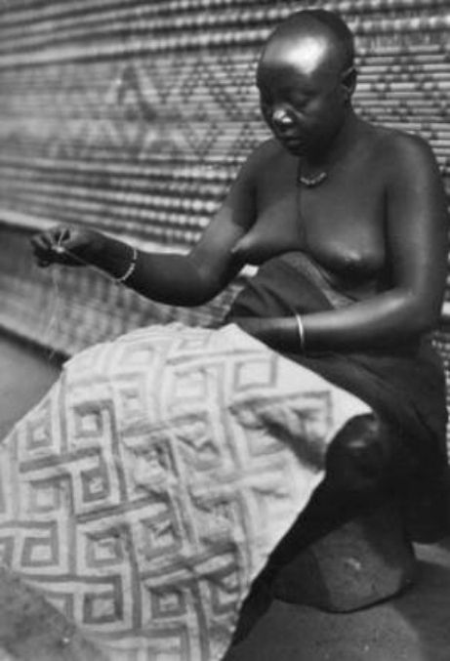

Fig. 5. Kuba woman embroidering a geometric textile design similar to the zig-zag keloid scars of the Pygmy (after www.ezakwantu.com.)

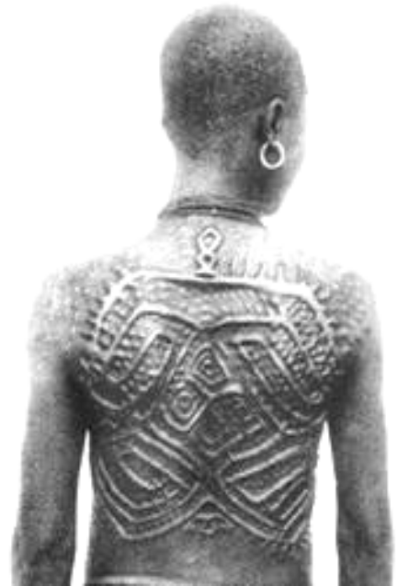
Fig. 6. Kuba Shoowa woman with keloid scars that suggest a connection with a Bwoom mask (after http://www.ezakwantu.com/Kuba%20Shoowa%20Scarifacatoin%200001.jpg )

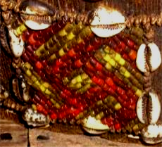
Fig. 7. Right-handed Swastika design in red at the back of the head of the Atlantika Mboom mask.

Two traditions trace Bwoom's origin to the problem of royal succession: King Miko mi-Mbul killed the children of his predecessor so that he could succeed to the throne. However, he subsequently went mad. (Even today the issue of royal succession is critical to West and Central African peoples as the slaughter at Yendi in northwestern Ghana illustrates in 2004 when the king of Yendi murdered the offspring of his rival in Tamale.) Although King Miko mi-Mbul eventually regained sanity, he would lapse into madness each time he wore the Mwaash a Mbooy, the sole royal mask.
A Pygmy, an outsider who, by his small stature, was considered even less challenge than a Kuba commoner, offered the king a Bwoom mask as a gift, and Miko accepted it. Its effects were profound, yet covert. With the Bwoom mask the king became like those whom he had previously despised. He learned empathy. Another version is that King Miko mi-Mbul, who was known as a great dancer, was seduced by the Pygmy’s mask because the King Miko mi-Mbul danced with it so well in the rites, despite its overtly humble character.
The king was able to enter the soul of the commoners and therefore perceive their innermost desires for a just rule. In order to soften the critique of royal malfeasance, in both versions the King is reputed to have made alterations to the mask that justified its inclusion in the royal repertoire (Cornet 1982:269). These accounts reify the need for royal power to be circumscribed (literally) by commoners "of low standing scarcely worthy of being embodied by the king" (Cornet 1975: 89).
The defiant performance of Bwoom opposes the regal Mwaash a Mbooy. The two act out a competition for one female in the royal mask trio, Ngady mwaash aMbooy (Cornet 1982:255). Mwaash aM-booy's dance is calm, stately and without passion, while Bwoom acts with pride and passion (Cornet 1982:255). Materially, the masks are easily differentiated by material, for Bwoom is carved from a single piece of wood by male artisans and Mwaash a Mbooy is woven by women as a textile. Here a tension and quasi-contradiction is implicit: commoner men manufacture the mask of commoners and women, ostensibly the consorts of the king, manufacture the mask of royalty. Bwoom appears apotropaically on the nkan or "initiation fence" of the Kuba, prohibiting entrance to all not in the rite (Vansina 1955:150-151). Bwoom does not appear at funerals and is never interred with the king or other dignitaries because it is the spirit of the living commoners not of the king (Cornet 1982:270). The costume is similar to that of Mwaash a Mbooy: heavy with profuse layers of raffia-cloth, bead and cowry decoration, leopard skins, anklets, armlets, and fresh leaves. Eagle feathers or other prestigious media are added to the crown of the head when the mask is danced.

3. Kuban Kings as Ndop Sculptures Communicating with the Pygmies

In addition to the Kuban masks there is also a tradition of idealized effigy sculptures of Kuba kings. Praised as "God on Earth," the king, nyim, is a divine ruler who controls fertility and communicates with
Mboom, that is, the knowledge of natural resources provided by the Pygmys.
Ndop figures are idealized portraits of individual Kuba rulers. The ndop ruler sits cross-legged on a raised platform. His demeanor expresses both aloofness and composure. The belts, armbands, bracelets, shoulder ornaments, and special projecting headdress are all elements of royal regalia. Ndop figures were believed to represent and honor the spirit of the nyim and serve as a point of contact with his spirit.
The royal court at Nsheng is a hierarchical complex of councils and titled officials who advise the king and balance his power. Outlying Kuba chiefdoms are largely autonomous, organized on models analogous to those of the capital but on a lesser scale (Vansina 1964:98-99; 1978:216). Kuba society parallels governmental organization in that it is stratified. Yet the Kuba people prize individual hard work and achievement, and while one’s position of birth may secure advantage, it is not binding (Vansina 1964:188;1968:13,15).
Most Royal sculptures are modern renditions carved during a ruler’s lifetime and finally placed near the dying king to receive the royal power, which would then be transferred to his successor. The earliest examples show the workmanship of a few artists who had developed a stylistic convention that was able to serve many regents. In time these figures with carefully executed details seen in the carefully shaped headdresses and bodies degenerated into cruder examples without fine details. The following two examples reflect this transition from carefully controlled atelier figures to cruder examples.

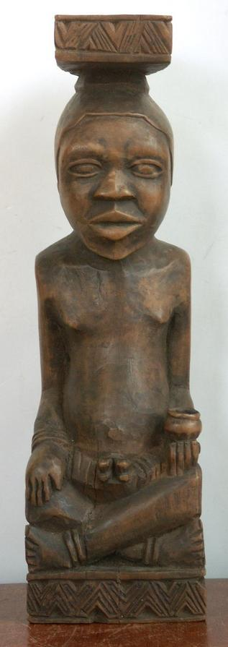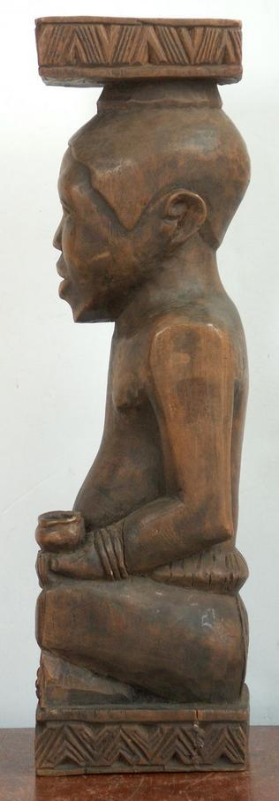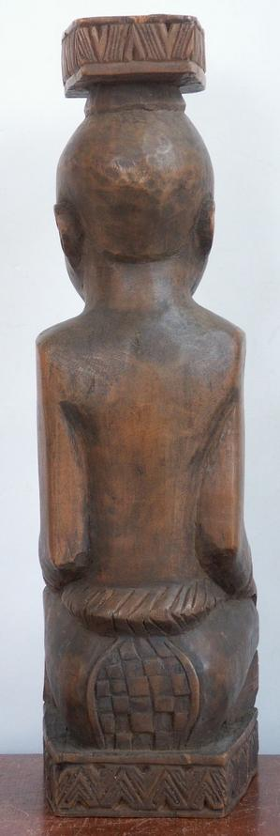
Fig. 8 a-c. Kuba Royal sculpture, earlier example with fine details. Height: 12.25x3.75x3.5 inches. Weight 2.1 pounds (960gm), ca. early 20th century. Atlantika Collection. In the left hand a small cup possibly containing a bilongo substance suggests that this king was also a nganga’a n’kisi or medical specialist.

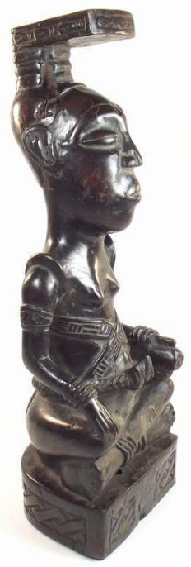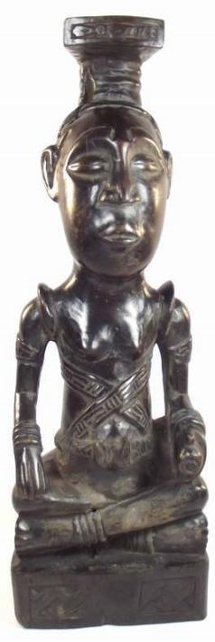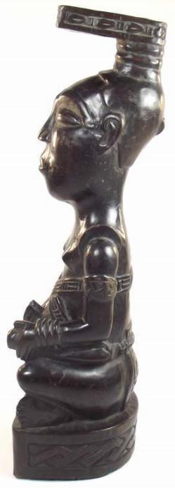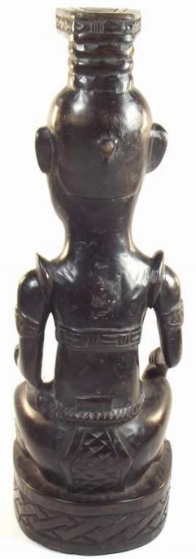
Fig. 9 a-dc. Kuba Royal sculpture, later example, ca. mid 20th century. Atlantika Collection. The short sword in his left hand held with handle out, indicates the non-aggressive posture of the nyim.

4. The Kongo Incorporate Pygmy Knowledge into Their Min’kisi

In at least two impressive Royal locations the Kongo recognized the medical contributions of Pygmy lore by their own specialists: Mbanza Kongo and Loango. In order to incorporate pygmy expert medical knowledge into Kongo culture, Ntinu Lukeni married the daughter of a local pygmy (?) spiritual leader, Manikabunga, established the town of Mpemba Kasi (near the modern village of Matadi in the Kwilu valley), where the original Kongo Kingdom rulers would be buried, and he initiated the tradition of using pygmy (?) medicines (bilongo) in conjunction with miN’kisi which therefore may have had their origins with Manikabunga.

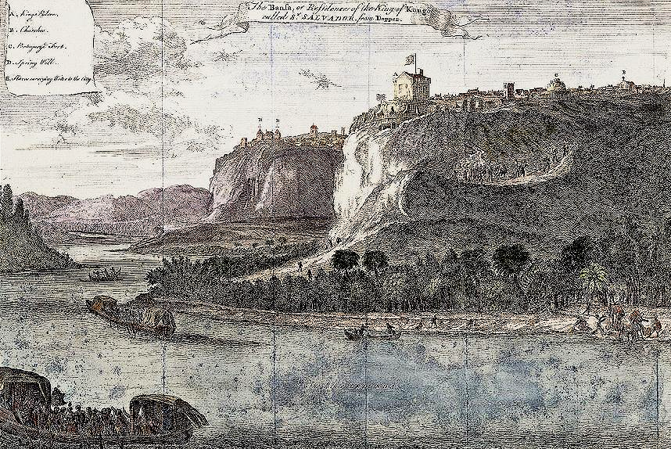
Fig. 10. Mbanza Kongo, “The Bansa or residence of the King of Kongo called Ste. Savadore [by the Portuguese] from Olfert Dapper, Description de l’Afrique (Amsterdam: W. Waesberge, Boom et Van Someren, 1686), where the Kingdom’s medical specialists, nganga or ngang’a n’kisi gathered to assess and confirm local pygmy knowledge. The Nzadi or Congo River in the foreground shows two laden trade vessels.

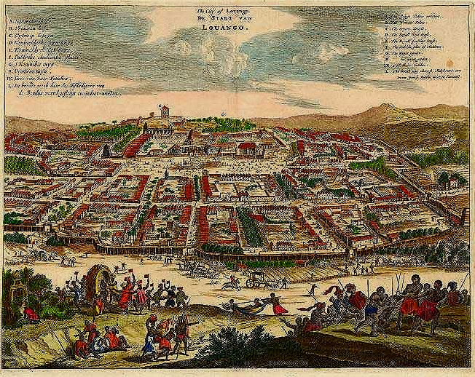
Fig. 11. "The City of Lovango [sic., Luoango], De Stadt van Luoango." After Olfert Dapper Umbständliche und eigentliche Beschreibung von Africa (Amsterdam, 1670). Another important city of the Kingdom of the Kongo, where medical specialists, nganga or ngang’a n’kisi gathered to assess and confirm local pygmy knowledge.

5. The Kongo people incorporate Pygmy Knowledge into their Nkisi

N’kisi can take many forms such as baskets, pots, snail shells, as well as statuettes. In practice, a priest (nganga’a n’kisi) acts on behalf of the individual client to prepare the n’kisi to accept its medicines, the bilongo, that make it an active agent. Then the client tests the effective potency of the elements in the bilongo in actual experience of them with the intermediary of the nganga and is cautioned to avoid their powers.
In addition, the client must also attain a unification with the power of the n’kisi., This may be accomplished through the application of pigments (often white and red) to the skin that establish a physical connection between the client, the metonymic colored pigments of the powerful dead and the pigments on the n’kisi sculpture (MacGaffey 1986: 139-141). White pigment derived from Kaolin or white clay (mpemba) signifies “land of the dead” or “cemetery” and is found in streambeds and corresponds to the belief that “the dead live in or under the water and are white in color”. Another important pigment is red ochre (nsadi) “also associated with the dead’ and implies “transition” from one state of being to another, i.e., from death to life (Van Wing 1959: 206 as cited by MacGaffey 1986: 140). At the same time through the actual physical application of red and white pigments to the skin, the client establishes a direct connection with the active agency of the ancestors. On the one hand, the effective potency of the contents of the bilongo can be discouraged, since these active agents may have been responsible for the difficulty in the first place. On the other hand the physical application of pigments to the skin may invoke healing by invoking the metonymic power of the ancestors (MacGaffey 1986: 141).

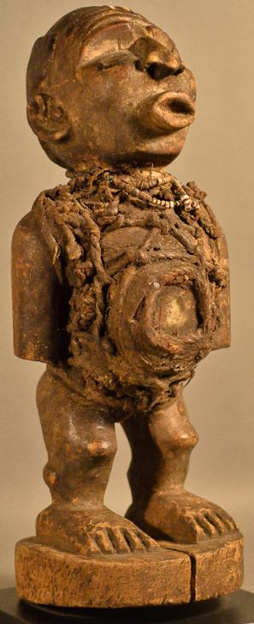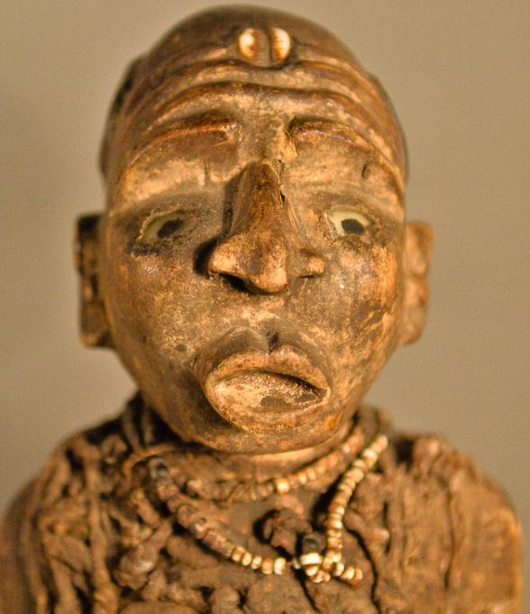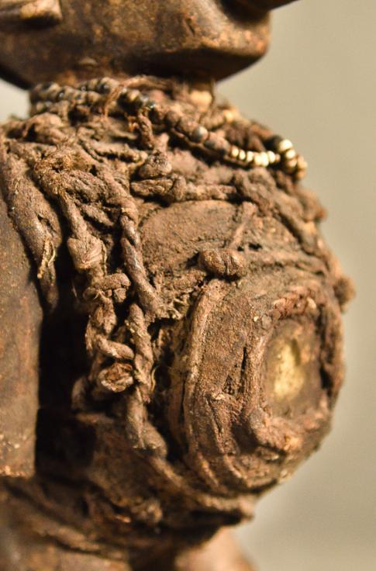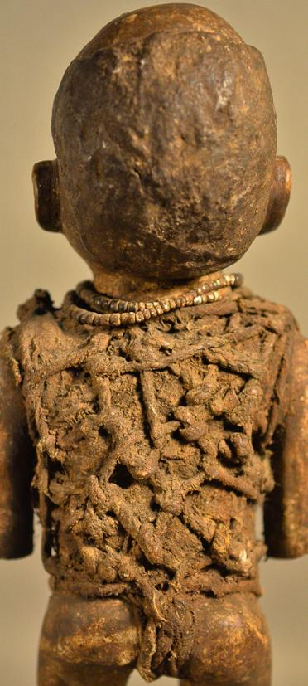
Fig. 12 a-d. N’kisi, BaKongo people, Democratic Republic of the Congo, 19th cent., wood, fiber, beads, and leather, Atlantika Collection.

This n’kisi (Fig. 7 a-d) is a wooden sculpture with the physical attributes of beads, fibers holding a medical sachet containing mysterious, and unseen medicinal paraphernalia. All n’kisi are inanimate and powerless until they have been activated by a specially prepared medicine or bilongo. This Nkisi has a classic Kongo face with expectant glass eyes and wrinkled brow (suggestive of the serious effort being exerted. Its forehead is adorned with a cowry shell or "kodya" in Kikongo, which evokes the word "kola", "to be strong", the exhortation of this powerful n’kisi, demonstrated by protruding lips and everted nose indicating the need for intentional breathing. Bent knees characterize all Kongo sculptures indicating that this is an animate being and not a dead object. A protruding belly is the location of the most important feature since it is covered with bilongo objects -- wrappings of rope, roots and a leather pouch with a transparent crystal representing kalunga, "the watery threshold between the world of the living and the world of the dead". This pouch or sachet also contains other powerful but unseen, hence mysterious, objects such as efficacious insects and snake teeth). All of these unseen objects are affixed with secret types of knots securing these hidden objects with their mysterious powers to the body and by sympathetic magic to that of the patient. Its arms are at its side, showing attentiveness to the suppliant and are consistent with well-carved ears suggesting that it is ready to hear entreaties. A small, beaded, white, shell necklace is encrusted with libations after years of use (MacGaffey: 1988).

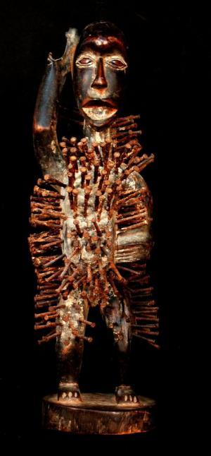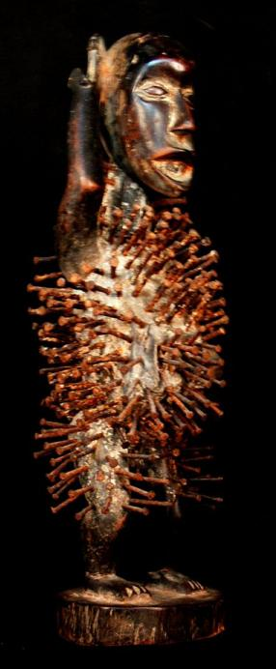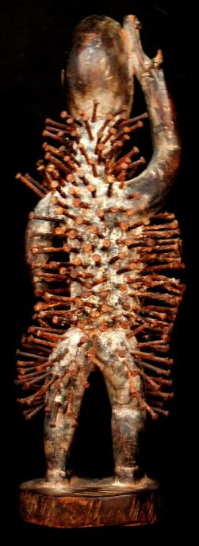
Fig. 13 a-c. N’kisi nkondi, BaKongo people, Democratic Republic of the Congo, 19th cent., wood and nails, Atlantika Collection. 12.20 inches high, Weight: 1.19 pounds.

The “Smasher” or “Lion” (Fig. 13 a-c) is a kind of n’kisi nkondi “in which pieces of iron are often hammered into its surface commemorating the swearing of oaths and the concluding of alliances (Laman 1953, vol. 3, p. 86). This n’kisi’s construction follows the classic Kongo protocol. Bent knees signify it is an animate being activated by the bilongo or medicine that has been applied to it by the and not a dead object. Its posture signifies that it is actively communicating with the client and that has come to have the power to activate the. The partly open mouth or bamuna represents the vibrations that have the power to activate the breathing of the mpungo for the n’kisi is ready to speak and is open to the Sun.. The large eyes suggest that the power of Kalunga is present for Klunga speaks through the eyes and is ready to challenge (mambo) the client. The nails or nkonso embedded in the figure represent strongly felt commitments or agreements made by the N’kisi, a physical manifestation of an emotional event such as desires, requests for protection, defense and empowerment each sealed with a solemn vow or “tied mambo” (Thompson 1978).
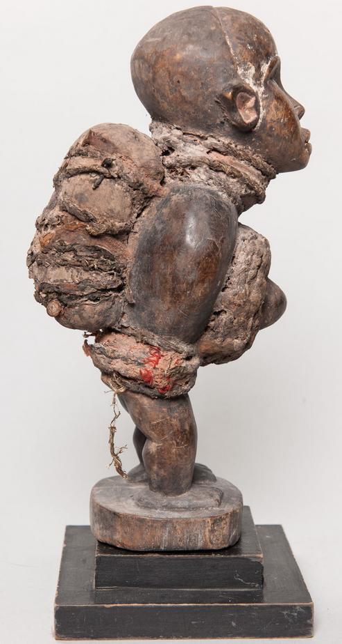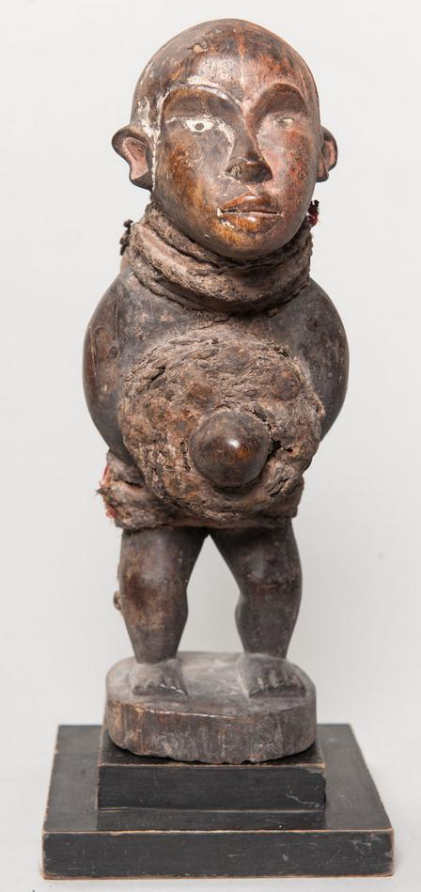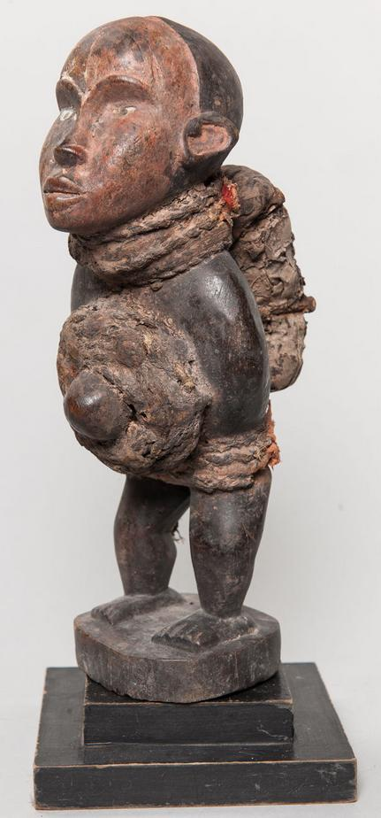
Fig. 14 a-c. N’kisi nkondi mazita, BaKongo people, Democratic Republic of the Congo, 19th cent., wood, fiber, beads, and leather, Atlantika Collection.

This particular n’kisi nkondi mazita uses knots called mazita (“tying up”) as a compilation of problems that are to be solved. The knot tying process involves slicing up palm leaves and tying them in knotted bundles on behalf of the “client” seeking solutions by the priest (nganga’a n’kisi). Each client request of assistance and the acknowledgement of the request by the nganga’a n’kisi is recorded by each knot. In practice, knots have ten different forms according to Barbaro Martinez-Ruiz (2013:168-169).
1) Nkeka kanga-single knot signifies closure of a single issue
2) Mazita a tatu-several knots tied in a row signifying difficult issues
3) Zeta seka kia kubula-broom like knot signifying spiritual cleansing
4) Zita lubamba-circular knots binding grass in a circle signifying completion
5) Seve kia lukamba-two knots in figure eight signifying restoration of goodwill with deceased
6) Zita dia vakika-reef knot tying two ropes together signifying tying multiple issues together
7) Zita dis kanga-butterfly knot ties along length of rope signifying silencing antagonisms
8) Simi dia ndala-cover used to seal wine bottle signifying issues sealed temporarily
9) Zita a nkita-end of rope knotted to secure its strands signifying cure of illnesses
10) Nsoko wa diya-helix knot signifying three components: head (psychological issues). Upper torso (physical issues), lower body (ancestor issues).

This n’kisi has carved ears that are everted to hear the requests of clients and hopefully and to provide solutions as well!

References:

Adams, Monni. 1988. 8th century Kuba king figures, African Art 21(3): 32-38, 88.
Belepe, Bope. 1974. Etude socio-morphologique des masques Bwoom des Kuba: Memoire de licence en histoire. Lubumbashi: Université Nationale du Zaire.
Belepe, Bope. 1981. Les oeuvres plastiques Africaines comme documents d'histoire: Le cas des statues Royales Ndop des Kuba du Zaire, AfricaTervuren 25 (1): 9-17.
Binkley, D. 1987. Avatar of power: Southern Kuba masquerade figures in funerary context, Africa 57 (1).
Binkley, D. 1990. Masks, space and gender in southern Kuba initiation ritual, Iowa Studies in Art. Vol. 3, Art and Initiation in Zaire. Iowa City: The University of Iowa.
Brett-Smith, Sarah. 1983. “The Doyle Collection of African Art,” Record of the Art Museum, Princeton University, 42(2): 2+8-34.
Kuba du Zaire, Africa Tervuren 27(1): 9-17.
Binkley, D. 1987. Avatar of power: Southern Kuba masquerade figures in funerary context, Africa 57 (1).
Binkley, D. 1990. Masks, space and gender in southern Kuba initiation ritual, Iowa Studies in Art. Vol. 3, Art and Initiation in Zaire. Iowa City: The University of Iowa.
Claerhout, A. 1976. Two Kuba wrought-iron statuettes, African Art IX (4): 60-64.
Cornet, J. 1972. Art de l'Afrique Noire au pays du fleuve Zaire. Brussels: Arcade.
Cornet, J. 1975. Art from Zaire: 100 Masterworks from the National Collection. New York: African-American Institute.
Cornet, J. 1982. Art royal Kuba. Milan: Sipiel.
Ehret, Christopher. 2002. The civilizations of Africa: a history to 1800. Charlottesville: Virginia: University of Virginia Press.
Forbath, Peter. 1977. The River Congo. Boston: Houghton Mifflin.
Laman, Karl. 1953. The Kongo. 4. vols. Stockholm: Victor Pettersons.
MacGaffey, Wyatt. 1986. Religion and society in central Africa: the Bakongo of Lower Zaire. Chicago: University of Chicago Press.
MacGaffey, Wyatt. 1988. “Complexity, astonishment and power: the visual vocabulary of Kongo minkisi,” Journal of African Studies, (14:2), 188-203.
Martinez-Ruiz, Barbaro. 2013. Kongo Graphic Writing and other Narratives of the Sign. Philadelphia: Temple University Press.
Rosenwald, J. B. 1974. “Kuba king figure,” African Art, VII (3).
Schadeberg, Thilo. 1999. “Batwa: the Bantu name for the invisible people.” In Challenging Elusiveness: Central-African Hunter Gatherers in a Multidisciplinary perspective, ed. K. Beibrouck, S. Elders, and G. Rossel. Leiden: CNWS, 21-39.
Thompson, Robert Farris. 1978. “The Grand Detroit N’kondi,” Bulletin of the Detroit Institute of Arts 56 :4, 206-217.
Torday, E. and T. A. Joyce. 1911. « Notes ethnographiques sur les peuples communement appeles Bakuba, ainsi que sur les peuplades apparentees, les Bushoongo. » In Annales du Musee Royal du Congo Belge, Ethnographie et Anthropologic., serie III, tome II, fasc. 1. Brussels: Tervuren.
Vansina, Jan. 1955 “Initiation Rituals of the Bushong,” Africa 25(2): 138-153.
Vansina, Jan. 1964. Le royaume kuba. Tervuren: Musée royal de l'Afrique centrale.
Vansina, Jan. 1978. The children of Woot. A history of the Kuba peoples. Madison: University of Wisconsin Press/Dawson.
Vansina, Jan. 1984. Art History in Africa. London: Longman.
Van Wing, Joseph Hubert Leopold. 1941. Études Bakongo. II. Religion et magie. Institut royal colonial belge. Section des sciences morales et politiques. Mémoires, collection in-8°, t. IX, fasc. 1. Brussels: Desclée de Brouwer.
Van Wing, Joseph Hubert Leopold. 1959. Études Bakongo. Brussels: Desclée de Brouwer.
Walker Art Center. 1967. Art of the Congo. Minneapolis: Walker Art Center.

(Note: I have used the term "Pygmy" here for the sake of simplicity, although I am aware of its non-African origin and its negative connotation in African contexts.)

